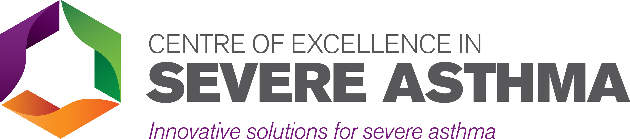

Workshop on the Assessment and Management of Unexplained Breathlessness and Dysfunctional Breathing
Travel bursary application
Deadline: COB 01 February 2019

The Centre of Excellence in Severe Asthma is providing bursaries to support the professional development of nursing and allied health professionals. A limited number of bursaries are available to interested clinicians attending the upcoming “Workshop on the Assessment and Management of Unexplained Breathlessness and Dysfunctional Breathing” to be held at the Hunter Medical Research Institute in Newcastle, NSW on 04 April 2019.

More information about the workshop is available at:
https://www.severeasthma.org.au/breathlessness-workshop/

Eligibility
Funds are available for nursing and allied health clinicians to support travel and accommodation expenses. Domestic economy airfares and a single night of accommodation in Newcastle will be supported. A limited number of bursaries will be available.

To apply, complete the attached travel bursary application form and return to severeasthma@newcastle.edu.au by COB 01 February 2019. Late applications will not be considered.

Workshop Travel Bursary Application

Applicant Name:
Position Title:
Affiliation (e.g. Institute / Hospital):

Experience & Interest: Please provide a brief summary of your experience and interests relevant to unexplained breathlessness and dysfunctional breathing and how you expect this bursary will support your professional development.

Signature:
Name (Please Print):
Date Prepared:

Applications should be submitted by email to: severeasthma@newcastle.edu.au. If you have any questions, please contact Steven Maltby (steven.maltby@newcastle.edu.au or 02 4042 0173).

